**LAB WORK – 01**

**What is DBMS ?**

A Database Management System (DBMS) is a software system that is designed to manage and organize data in a structured manner. It allows users to create, modify, and query a database, as well as manage the security and access controls for that database.DBMS provides an environment to store and retrieve the data in coinvent and efficient manner.

**Key Features of DBMS**

* **Data modeling:** A DBMS provides tools for creating and modifying data models, which define the structure and relationships of the data in a database.
* **Data storage and retrieval:**A DBMS is responsible for storing and retrieving data from the database, and can provide various methods for searching and querying the data.
* **Concurrency control:** A DBMS provides mechanisms for controlling concurrent access to the database, to ensure that multiple users can access the data without conflicting with each other.
* **Data integrity and security:** A DBMS provides tools for enforcing data integrity and security constraints, such as constraints on the values of data and access controls that restrict who can access the data.
* **Backup and recovery:** A DBMS provides mechanisms for backing up and recovering the data in the event of a system failure.
* **DBMS can be classified into two types:** Relational Database Management System (RDBMS) and Non-Relational Database Management System (NoSQL or Non-SQL)
* **RDBMS:**Data is organized in the form of tables and each table has a set of rows and columns. The data are related to each other through primary and foreign keys.
* **NoSQL:**Data is organized in the form of key-value pairs, documents, graphs, or column-based. These are designed to handle large-scale, high-performance scenarios.

# Application of DBMS

# There are different fields where a database management system is utilized. Following are a few applications that utilize the information base administration framework.

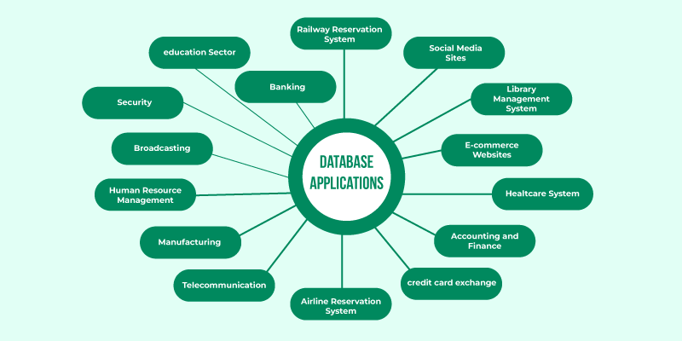

### ****1. Railway Reservation System****

In the rail route reservation framework, the information base is needed to store the record or information of ticket appointments, status of train’s appearance, and flight. Additionally, if trains get late, individuals become acquainted with it through the information base update.

### ****2. Library Management System****

There are many books in the library so; it is difficult to store the record of the relative multitude of books in a register or duplicate. Along these lines, the data set administration framework (DBMS) is utilized to keep up all the data identified with the name of the book, issue date, accessibility of the book, and its writer.

### ****3. Banking****

Database the executive’s framework is utilized to store the exchange data of the client in the information base.

**4. Education Sector**

Presently, assessments are led online by numerous schools and colleges. They deal with all assessment information through the data set administration framework (DBMS). In spite of that understudy’s enlistments subtleties, grades, courses, expense, participation, results, and so forth all the data is put away in the information base.

**5. Credit card exchanges**

The database Management framework is utilized for buying on charge cards and age of month to month proclamations.

## Types of Databases

There are several types of databases, that are briefly explained below.

## ****Hierarchical Databases****

Just as in any hierarchy, this [database](https://www.geeksforgeeks.org/what-is-database/) follows the progression of data being categorized in ranks or levels, wherein data is categorized based on a common point of linkage. As a result, two entities of data will be lower in rank and the commonality would assume a higher rank. Refer to the diagram below:

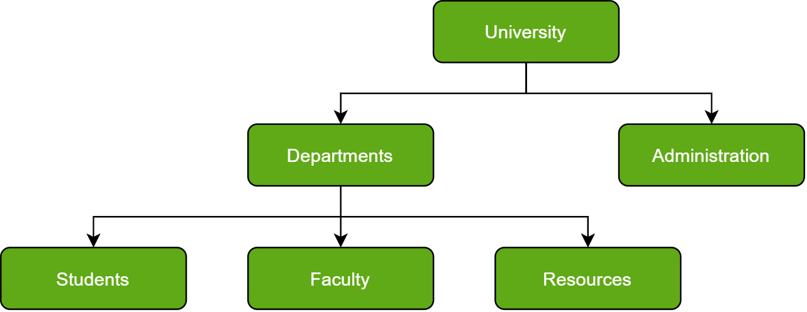

## ****Network Databases****

In Layman’s terms, a network database is a hierarchical database, but with a major tweak. The child records are given the freedom to associate with multiple parent records. As a result, a network or net of database files linked with multiple threads is observed. Notice how the Student, Faculty, and Resources elements each have two-parent records, which are Departments and Clubs.

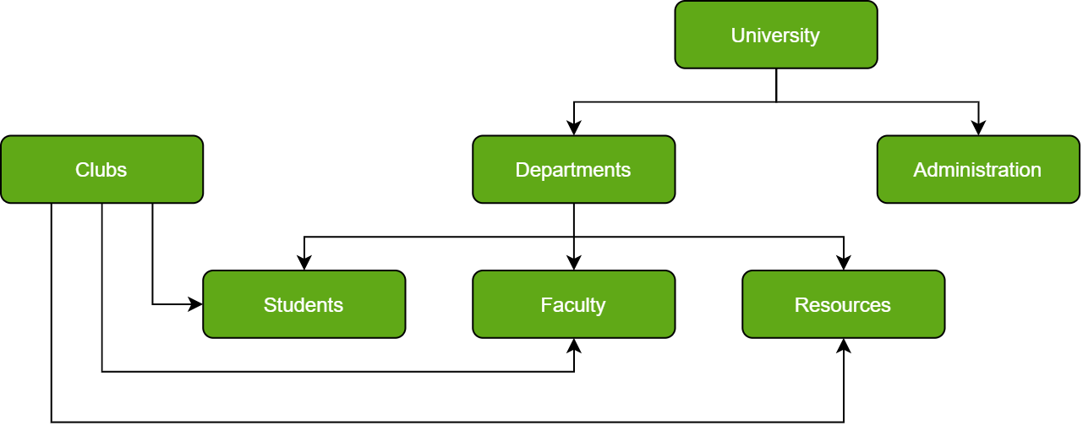

## Object-Oriented****Databases****

Those familiar with the Object-Oriented Programming Paradigm would be able to relate to this model of databases easily. Information stored in a database is capable of being represented as an object which response as an instance of the database model. Therefore, the object can be referenced and called without any difficulty. As a result, the workload on the database is substantially reduced.

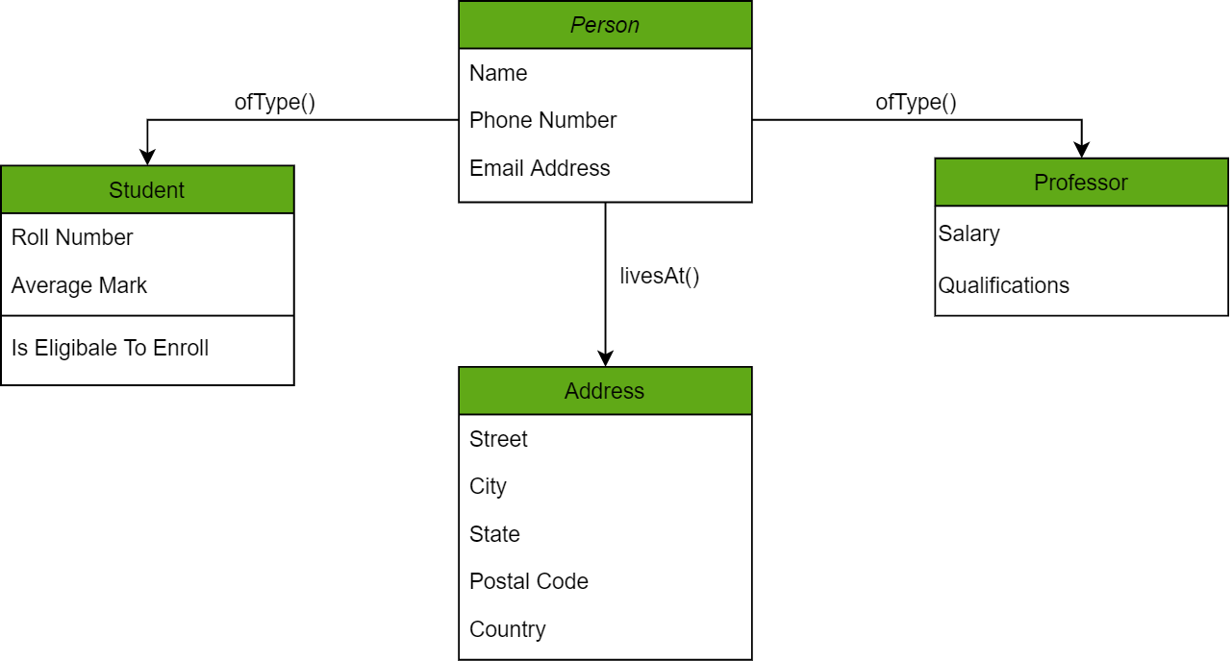

## ****Relational Databases****

Considered the most mature of all databases, these databases lead in the production line along with their management systems. In this database, every piece of information has a relationship with every other piece of information. This is on account of every data value in the database having a unique identity in the form of a record.

Note that all data is tabulated in this model. Therefore, every row of data in the database is linked with another row using a primary key. Similarly, every table is linked with another table using a foreign key.

Refer to the diagram below and notice how the concept of ‘Keys’ is used to link two tables.

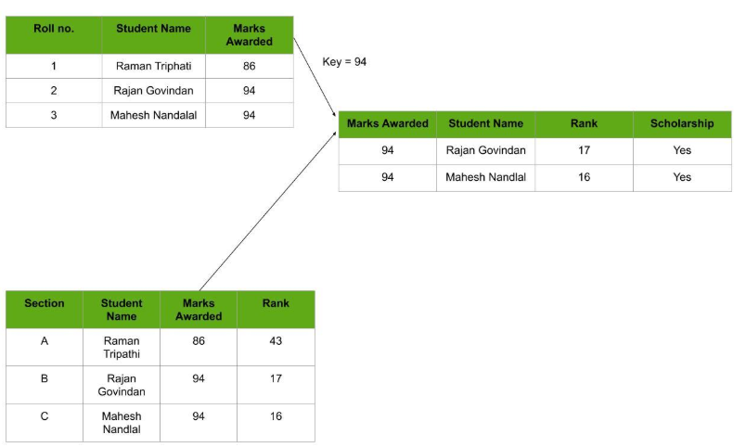

## Cloud Databases

A cloud database is used where data requires a virtual environment for storing and executing over the cloud platforms and there are so many cloud computing services for accessing the data from the databases (like SaaS, Paas, etc).

## Centralized Databases

A centralized database is basically a type of database that is stored, located as well as maintained at a single location and it is more secure when the user wants to fetch the data from the Centralized Database.

## Personal Databases

Collecting and Storing the data on its own System and this type of databases is basically designed for the single user.

## Operational Databases

It is used for creating, updating, and deleting the database in real-time and it is basically designed for executing and handling the daily data operation in organizations and businesses purposes.

## ****NoSQL Databases****

A NoSQL originally referring to non SQL or non-relational is a database that provides a mechanism for storage and retrieval of data. This data is modeled in means other than the tabular relations used in relational databases.

A NoSQL database includes simplicity of design, simpler horizontal scaling to clusters of machines, and finer control over availability. The data structures used by NoSQL databases are different from those used by default in relational databases which makes some operations faster in NoSQL. The suitability of a given NoSQL database depends on the problem it should solve. Data structures used by NoSQL databases are sometimes also viewed as more flexible than relational database tables.

**What is MYSQL**

Effective data management is crucial, Database Management Systems (**DBMS**) are used in this situation. Software for **managing**, **storing**, and **retrieving** data from **databases** is called a **database management system** (DBMS).

**MySQL** is one such popular DBMS. In this article, we will explore the importance of MySQL with its uses and discover why it is so important in databases.

**Why Use MySQL**

MySQL is a popular choice for managing **relational databases** for several reasons:

1. **Open Source:** MySQL is [open-source](https://www.geeksforgeeks.org/introduction-to-open-source-and-its-benefits/) software, which means it’s **free to use** and has a large community of developers contributing to its improvement.
2. **Relational:** MySQL follows the relational database model, allowing users to organize data into **tables** with **rows** and **columns**, facilitating efficient **data storage** and retrieval.
3. **Reliability:** MySQL has been around for a long time and is known for its **stability** and **reliability**.
4. **Performance:** MySQL is optimized for performance, making it capable of handling **high-volume transactions** and large datasets efficiently.
5. **Scalability:** MySQL can scale both **vertically** and **horizontally** to accommodate growing data and user loads. You can add more resources to a single server or distribute the workload across multiple servers using techniques like [sharding](https://www.geeksforgeeks.org/what-is-sharding/" \t "_blank) or [replication](https://www.geeksforgeeks.org/data-replication-in-dbms/).
6. **Compatibility:** MySQL is widely supported by many **programming languages**, [frameworks](https://www.geeksforgeeks.org/what-is-a-framework/), and tools. It offers connectors and [APIs](https://www.geeksforgeeks.org/what-is-an-api/) for popular languages like PHP, [Python](https://www.geeksforgeeks.org/python-programming-language/), Java, and more, making it easy to integrate with your existing software stack.
7. **Security:** MySQL provides robust **security features** to protect your data, including access controls, encryption, and auditing capabilities. With proper configuration, you can ensure that only authorized users have access to sensitive information.

**Applications of MySQL**

MySQL has used in various applications across a wide range of industries and domains, because of to its versatility, reliability, and performance. Here are some common applications of MySQL:

1. **E-commerce:**MySQL is extensively used in e-commerce platforms for managing **product catalogs**, **customer data**, orders, and transactions.
2. **Content Management Systems (CMS):** Many popular CMS platforms rely on MySQL as their backend database to store **website content**, **user profiles**, comments, and configuration settings.
3. **Financial Services:** MySQL is employed in **financial applications**, including banking systems, payment processing platforms, and accounting software, to **manage transactional data**, customer accounts, and financial records.
4. **Healthcare:** MySQL is used in **healthcare applications** for storing and managing **patient records**, medical histories, treatment plans, and diagnostic information.
5. **Social Media:** MySQL powers the backend databases of many social media platforms, including **user profiles**, posts, comments, likes, and connections.

# Difference Between DBMS and RDBMS

| **DBMS** | **RDBMS** |
| --- | --- |
| [DBMS](https://www.geeksforgeeks.org/introduction-of-dbms-database-management-system-set-1/) stores data as file. | [RDBMS](https://www.geeksforgeeks.org/rdbms-architecture/) stores data in tabular form. |
| Data elements need to access individually. | Multiple data elements can be accessed at the same time. |
| No relationship between data. | Data is stored in the form of tables which are related to each other. |
| Normalization is not present. | Normalization is present. |
| DBMS does not support distributed database. | RDBMS supports distributed database. |
| It stores data in either a navigational or hierarchical form. | It uses a tabular structure where the headers are the column names, and the rows contain corresponding values. |
| It deals with small quantity of data. | It deals with large amount of data. |
| Data redundancy is common in this model. | Keys and indexes do not allow Data redundancy. |
| It is used for small organization and deal with small data. | It is used to handle large amount of data. |
| Not all Codd rules are satisfied. | All 12 Codd rules are satisfied. |
| Security is less | More security measures provided. |
| It supports single user. | It supports multiple users. |
| Data fetching is slower for the large amount of data. | Data fetching is fast because of relational approach. |
| The data in a DBMS is subject to low security levels with regards to data manipulation. | There exists multiple levels of data security in a RDBMS. |
| Low software and hardware necessities. | Higher software and hardware necessities. |
| Examples:[XML](https://www.geeksforgeeks.org/xml-basics/), Window Registry, Forxpro, dbaseIIIplus etc. | Examples: [MySQL](https://www.geeksforgeeks.org/architecture-of-mysql/), [PostgreSQL](https://www.geeksforgeeks.org/what-is-postgresql-introduction/), [SQL](https://www.geeksforgeeks.org/what-is-sql/) Server, Oracle, Microsoft Access etc. |